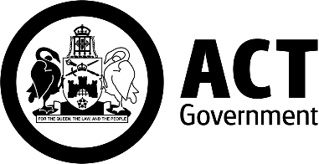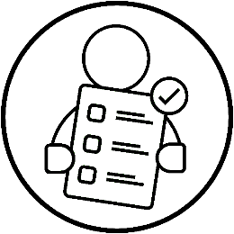

Events ACT Disability Inclusion Plan 2025–28
  - Part of the ACT Disability Strategy 2024–2033
  - June 2026
  - Easy English Version

What is in this guide?
How to use this document 3
About this plan 6
1. Accessible Information 9
2. Accessible event environments 13
3. Attitudes and behaviours 16
Access and connectivity 19
Contact information 22

How to use this document
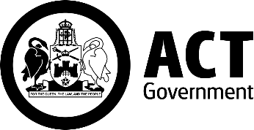
We are Events ACT.
We are part of the ACT government.

We wrote this document.

We wrote some words in bold.

We explain what these words mean.
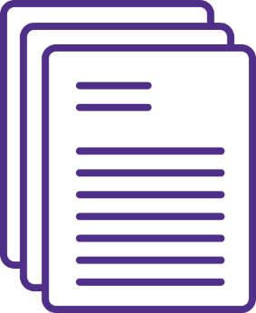
This is a long document.
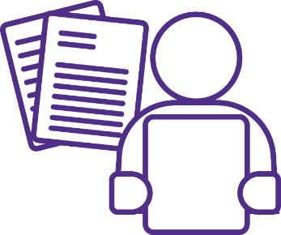
You don’t need to read it all at once.
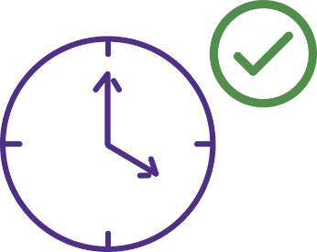
You can take your time.
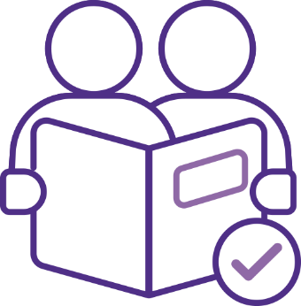
You can ask someone you trust for support to:
- read this document

- find more information.
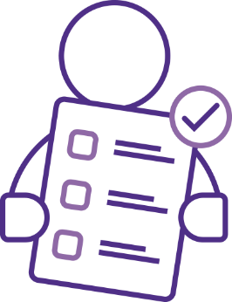
This is an Easy Read summary of another document.

A summary only includes the most important ideas.

About this plan
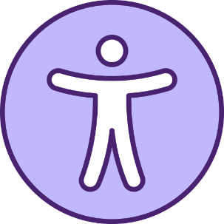
This document is about our Disability Inclusion Plan.
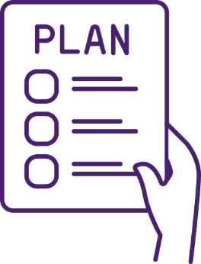
We just call it the plan.
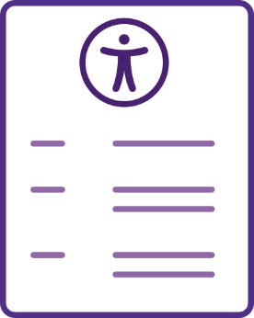
The plan tells you about how we can make the work that we do more accessible and inclusive for everyone in the community.
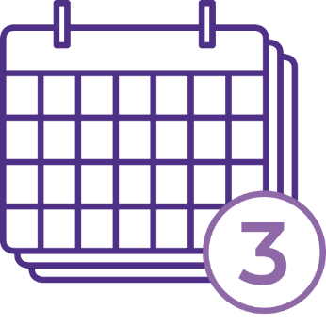
The plan goes over 3 years.

The plan has 3 focus areas.
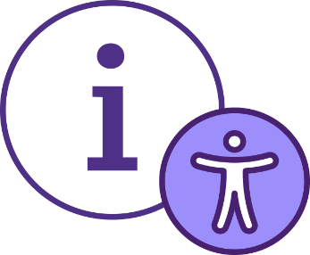
The focus areas are:
- Accessible Information
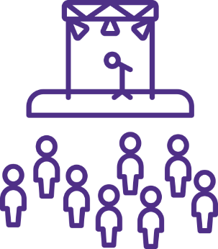
- Accessible Event Environments

- Attitudes and Behaviours.

The focus areas are for the events in the plan.
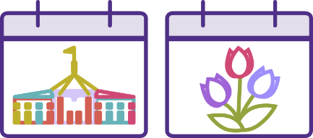
The events in the plan are the Enlighten and Floriade festivals.

There is another focus area for all the work we do in ACT.
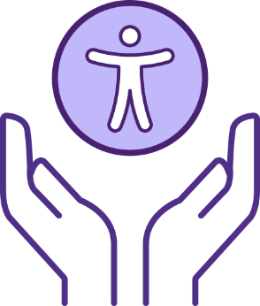
This focus area is called Access and Connectivity.

1. Accessible Information
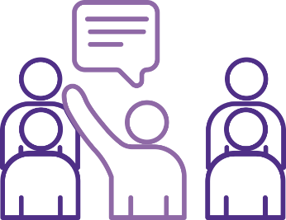
This means we want to change the way we communicate with the community.

This means we want to give information in different ways so that more people can:
- get information about the events

- be included while they are at the events

- get access to the events

- be involved in the events.
To make sure more people can get information about the events, we will do things like:
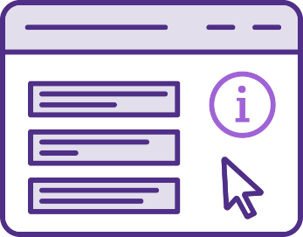
- make event websites and other online information more accessible
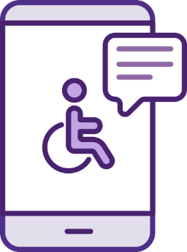
- share information about accessible activities with the Office for Disability
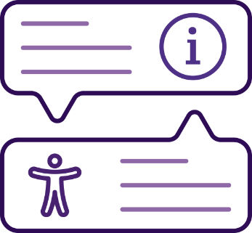
- share information about the inclusive parts of events so people can plan for their needs.
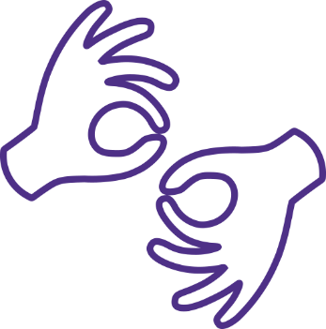
To make sure more people can be included when they are at the events, we will do things like:
- have Auslan interpreters for things like speeches
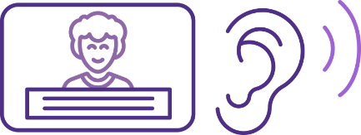
- see if we can make accessible content, like captioned videos and audio descriptions.

So that more people can get access to the events, we will do things like:
- make sure the ticketing services we use are accessible
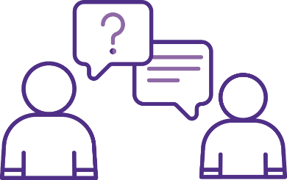
- ask people with disability how we can make getting tickets more accessible.
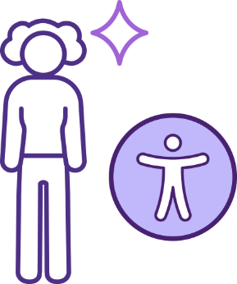
So that more people can be involved in the events, we will do things like:
- ask media guests, like performers, about their accessibility needs

- give support to the guests of the events of they need it.

2. Accessible event environments
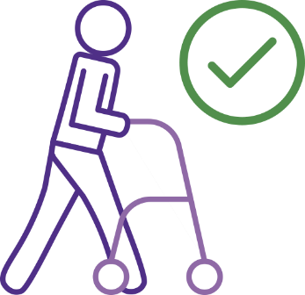
This means that we want to make the places where the events are held more accessible.
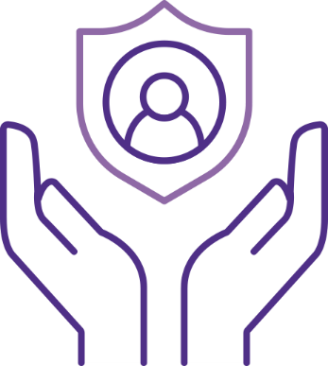
If we make events more accessible it will be safer and more inclusive for everyone, especially people with disability.
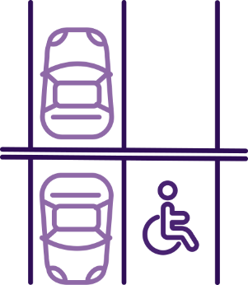
We will do this by:
- making sure it is easier to find accessible carpark spots
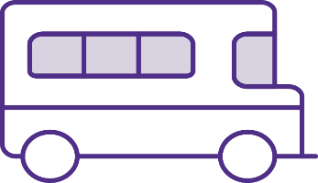
- making sure there is accessible transport to and from events, like shuttle buses

- making sure everyone can move around events easily

- making sure there is enough seating and other spaces for people with disability

- having accessible payment options, like online payment
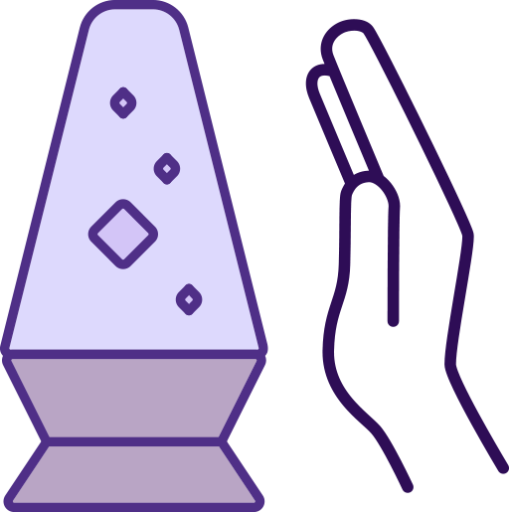
- making spaces that are friendly for people with sensory needs

- providing special maps so people can find their way around.

3. Attitudes and behaviours
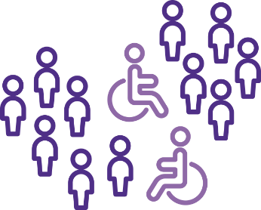
This means we want to make it so that people with disability are more included in the community.
To be more included in the community, people with disability should:

- be recognised and understood better

- get access to employment
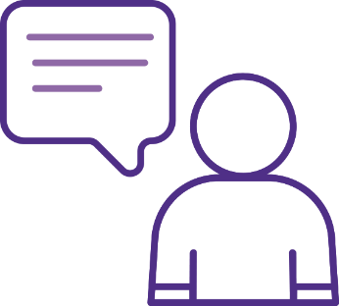
- have a say in accessibility and what happens in the community.
To make sure people with disability are recognised and understood better, we will do things like:

- make it easier for people with hidden disabilities to get support
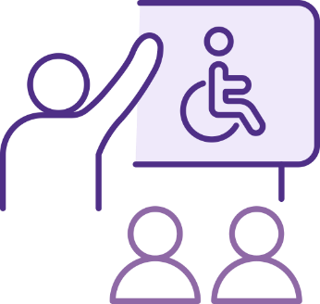
- give our staff the chance to do disability inclusion training.
To help people with disability get access to employment, we will:
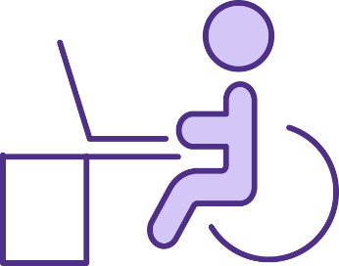
- look at ways we can give career opportunities for people with disability
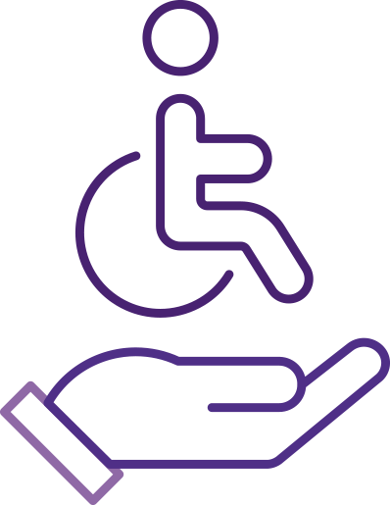
- support people with disability when they are working with us.
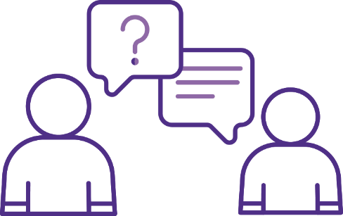
So that people with disability have a say in what happens at our events, we will:
- get feedback from people with disability about how to improve our events
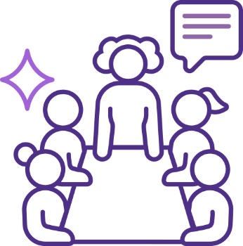
- make a group that gets people with disability to help plan and review our events.

Access and connectivity
To help our events be more accessible and inclusive, we have a plan to:
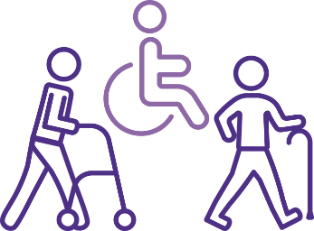
- make sure everyone can access places and services they need in the ACT
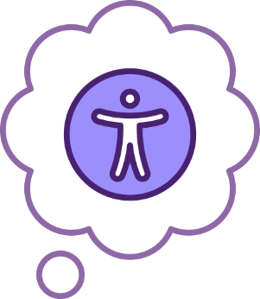
- make sure we think about accessibility in all the work we do.
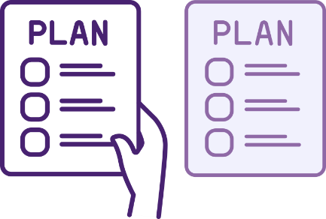
We have things we want to do for this plan, and for our next plan.
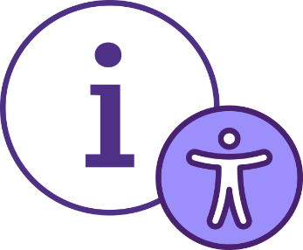
Things we want to do for this plan to help accessibility and inclusion in the ACT are:
- make more information and content accessible, like this Easy Read plan
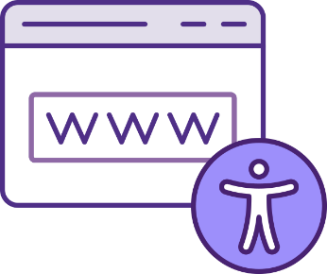
- make our digital communications easier to use. For example, our websites

- support people with disability and their families to access public spaces and events.
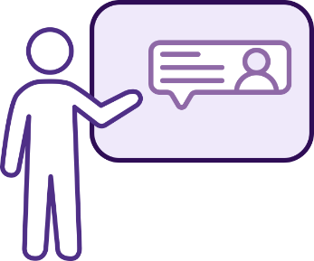
Things we want to do for our next plan to help accessibility and inclusion in the ACT are:
- train our staff on inclusive ways to communicate

- have the best accessibility standards we can on all the ACT government websites

- keep improving how people access all our events and how we promote them.

Contact information

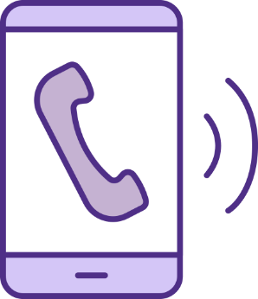
Call us
1300 554 114


Email us
events@act.gov.au


Visit our website
events.canberra.com.au

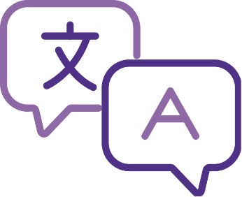
Do you need an interpreter?
Call the Translating and Interpreting Service or TIS on 13 14 50 and let them know what language you speak.

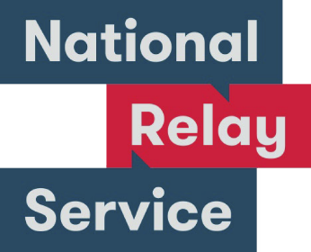
Use the National Relay Service
Use the National Relay Service or NRS if you are d/Deaf or find it hard to hear or speak to people on the phone.
Call 133 6777 and ask for 133 427, or visit the NRS website:
accesshub.gov.au/about-the-nrs

This document (job AI3007) was created by Scope (Aust) Ltd. using both licensed and custom images. This document must not be sold to third parties. The images must not be reused without permission. For more information contact Scope on 1300 472 673 or visit scopeaust.org.au

