**TEMPLATE****Attendee Event Evaluation Questionnaire**

Use the following questions as a starting point for developing your attendee survey. Consider what other information you would like to learn from your attendees. This might include information that supports a sponsorship partnership, or that helps you measure achievement of the objectives you have set for your event.

Ideally, copy and paste these questions into an online survey such as [SurveyMonkey](https://www.surveymonkey.com/) or [Google Forms](https://www.google.com/intl/en-GB/forms/about/) and adjust them to your individual needs.

**[Name of your event] Attendee Event Evaluation Questionnaire**

Thank you for agreeing to take part in our short survey about [Name of your event]. It will only take 5-10 minutes and we appreciate your feedback.

**Where do you normally live?**

* Canberra and surrounds (incl. Queanbeyan and Jerrabomberra)
* Interstate
* Overseas

**If Canberra and surrounds, what is the postcode where you live?**

* [Insert Textbox]

**If interstate, which state or territory?**

* NSW
* NT
* QLD
* SA
* TAS
* VIC
* WA

**If overseas, in which country do you live?**

* [Insert Textbox]

**In which of the following places do you recall seeing or hearing advertising about this year’s [Name of your event]?**

*[NOTE: Add any other options that apply to your event]*

* The [Name of your event] Facebook page
* The [Name of your event] Instagram page
* Facebook or Instagram ads
* Radio
* TV
* Posters
* Magazines
* Word of mouth
* Events ACT Website (events.canberra.com.au)
* Visit Canberra Website (visitcanberra.com.au)
* Other (please specify)

**Having attended [Name of your event] this year, did the experience exceed, meet, or fall below your expectations?**

* Exceeded my expectations
* Met my expectations
* Fell below my expectations

**Overall, how satisfied were you with the experience that you had whilst attending [Name of your event] this year?**

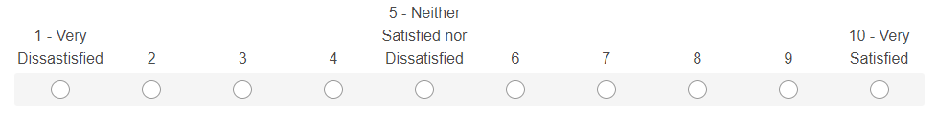

**Now thinking about specific elements of your experience, how would you rate [Name of your event] in terms of the following?**

*[Where 1 = Very poor and 5 = Excellent. Please select N/A if you did not experience any element]*

|  |  |  |  |  |  |  |
| --- | --- | --- | --- | --- | --- | --- |
| **Response** | **1**  **Very Poor** | **2** | **3** | **4** | **5 Excellent** | **N/A** |
| Activities/entertainment |  |  |  |  |  |  |
| Food and beverage options |  |  |  |  |  |  |
| Parking facilities |  |  |  |  |  |  |
| Customer service from staff (including volunteers and security) |  |  |  |  |  |  |
| Cleanliness of the event locations |  |  |  |  |  |  |
| Information signage at the event |  |  |  |  |  |  |
| Toilet/bathroom facilities |  |  |  |  |  |  |

**To what extent do you agree with the following statements regarding [Name of your event]?**

|  |  |  |  |  |  |
| --- | --- | --- | --- | --- | --- |
| **Response** | **Strongly Disagree** | **Disagree** | **Neither Agree nor Disagree** | **Agree** | **Strongly Agree** |
| It helps to make Canberra a more enjoyable place to live |  |  |  |  |  |
| It enhances community spirit, pride, and connection |  |  |  |  |  |

**Which of the following age groups do you belong to?**

* 18 – 24
* 25 – 34
* 35 – 44
* 45 – 54
* 55 – 64
* 65 – 74
* 75+ years
* I’d rather not say

**Are you?**

* Male
* Female
* Non-binary
* Prefer not to say
* Other (please specify)

**Do you have any feedback to help improve [Name of your event] in future?**

* [Insert Textbox]

**Thank you for completing our survey. If you would like to be informed about the event in the future, please provide your email address.**

**Tip: Consider a prize or incentive to encourage event attendees   
to complete your survey**